# **Technical Description of a For Loop**

## Hunter McIntosh

In computer science a for loop is a very powerful tool in a programmers arsenal. It loops through a section of code until a conditional statement is met. It has 4 parts, initialization, test condition, block of code and iteration/updation. This is shown more clearly in figure 1

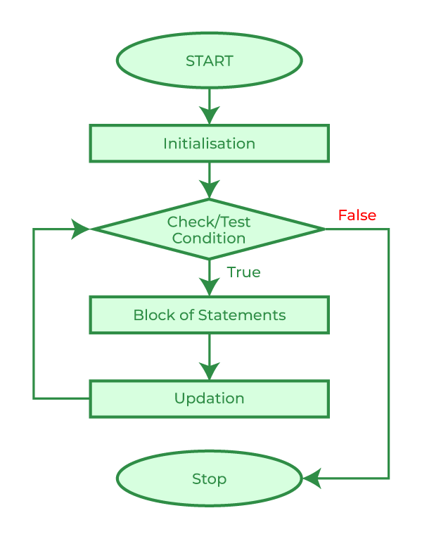

Example for loop

for( int i = 0; i < 5; i++){

System.out.println(i);

}

Discussion

**Initialization**

This part of a for loop is where you typically set the condition typically its an integer value along the lines of i=0; or something similar. Its job is to be the starting point for a counter that will track how many times you have looped through the code. Can be seen as the yellow section of the example for loop

**Check condition/test condition**

In the check condition you are establishing when the for loop should end. As shown in the green section of the example for loop it shows that the loop will end once i is greater than or equal to 5. The for loop will check that i is less than 5 then if that statement is true it will proceed to execute the block of code.

**Block of Statements**

As denoted by the pink section of the example this is what your loop will be running on each iteration. For the example that is outputting the value of i to the terminal but it can be any block of code you wish to repeat multiple times.

**Updation**

The updation part of the for loop is shown by the blue section in the example this is where you will state how you wish to iterate your initialized variable. In our example we are incrementing the value by 1 each time we do a pass through the loop . However this value can really be any type of value. Just avoid making it something that will lock you into an infinite loop.

**Conclusion**

A for loop is a block of code that will loop through a section of code a certain number of times until it meets a preset check condition. A user will determine an amount of time they wish to loop through a section of code then set up the check condition and initialization accordingly. They will then set an updation to tell them how many times they have looped through the code and execute that code the number of times using the for loop.